***Lyddie***

***Chapter 15 – “Rachael”***

Lyddie decided that she was going to keep the money a secret.  She wanted to tell Diana, but decided that she would wait until she had enough to pay off her family's debts completely and then surprise Diana by signing the [petition](http://bookbuilder.cast.org/view_glossary.php?book=111153&word=86345#curr) .

Lyddie knew once she had the money to pay off the [debts](http://bookbuilder.cast.org/view_glossary.php?book=111153&word=86346#curr)  she didn't care if she lost money by working less hours at the factory if she signed the petition.

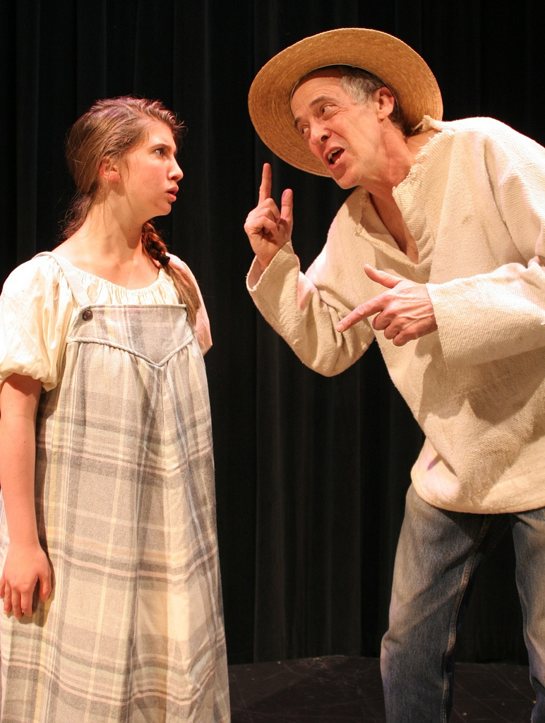

Suddenly, Tim, Mrs. Bedlow's son, came into the living room of the boardinghouse where Lyddie was and told her that she had a visitor.  Lyddie could not imagine who it was.  She knew that it wasnt Charlie or Luke and couldn't think who else might visit her.

Lyddie walked into the other room to see who the visitor was.  At first, she didn't even[recognize](http://bookbuilder.cast.org/view_glossary.php?book=111153&word=86347#curr) who it was.  Finally, she realized it was her Uncle Judah!



Right away, Lyddie became [suspicious](http://bookbuilder.cast.org/view_glossary.php?book=111153&word=86348#curr)  of why Uncle Judah was there.  He had never visited her before, why would he come now?

Lyddie asked him, "Why have you come? What is wrong?"

Uncle Judah said, "Well, Lyddie, you know your mother has never been well..."

Lyddie [gasped](http://bookbuilder.cast.org/view_glossary.php?book=111153&word=86349#curr) and said, "What have you done with her? Is she sick? Did she catch the fever?"

Uncle Judah looked [uncomfortable](http://bookbuilder.cast.org/view_glossary.php?book=111153&word=86350#curr)  and said, "No, she doesnt' have the fever, but we put her in the [asylum](http://bookbuilder.cast.org/view_glossary.php?book=111153&word=86351#curr) in Brattleboro"

Lyddie was [shocked](http://bookbuilder.cast.org/view_glossary.php?book=111153&word=86352#curr) .  "But that place is for crazy people!"

Uncle Judah said that Aunt Clarissa just couldn't handle it any more and she needed to send her away to get some [proper care.](http://bookbuilder.cast.org/view_glossary.php?book=111153&word=86353#curr)

Lyddie was so upset.  "What have you done with Rachel??"

Uncle Judah told her not to worry and that he had brought Rachel with him to stay with Lyddie.

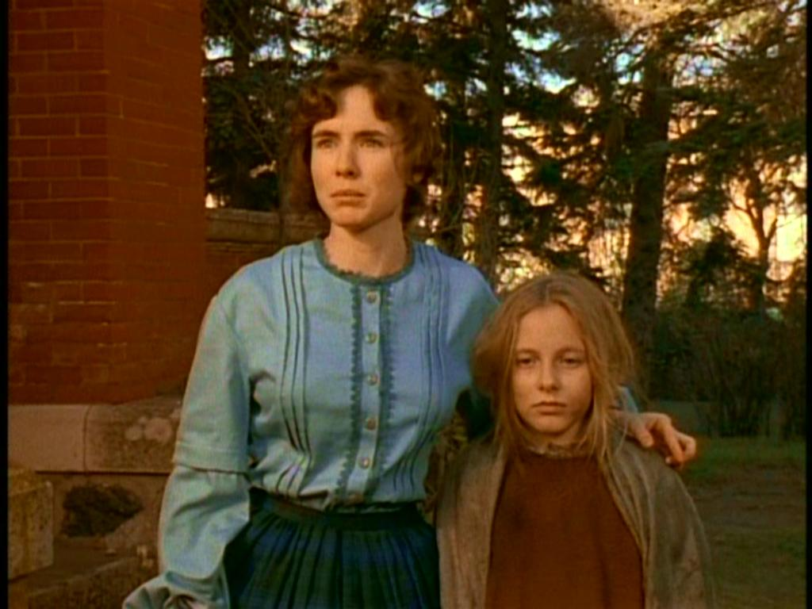

Lyddie went out to the[carraige](http://bookbuilder.cast.org/view_glossary.php?book=111153&word=86354#curr) that her uncle had come in to see Rachel.  Lyddie picked up Rachel from the carriage and noticed how thin and pale she looked.  Lyddie said hi to her sister but her sister seemed so sick that she [barely](http://bookbuilder.cast.org/view_glossary.php?book=111153&word=86355#curr) [recognized](http://bookbuilder.cast.org/view_glossary.php?book=111153&word=86356#curr)  her.

Lyddie made sure that she had all of Rachel's things and then she told Uncle Judah that she would go and get her mother as soon as she had enough money to pay off the debts and would [reunite](http://bookbuilder.cast.org/view_glossary.php?book=111153&word=86357#curr)  the family again on the farm.



Then, Uncle Judah said something that made Lyddie stop in her tracks.

"You can't go to the farm he said, we've sold it"

Lyddie couldn't believe it!

She said, "But you can't sell the farm without talking to my father!"

Uncle Judah said, "But I spoke with your father and he gave his consent"

Then, Uncle Judah left.



Lyddie brought Rachel inside.  She saw Mrs. Bedlow and she knew that she was mad.  One of the biggest rules at the boardinghouse was that there were not allowed to be any children or men.  Lyddie knew that Mrs. Bedlow was not going to be happy.

Lyddie spoke to Mrs. Bedlow and begged her to let Rachel stay for at least a week while she figured out what else she was going to be.

Mrs. Bedlow agreed, but made Lyddie promise that Rachel would not go outside because she did not want anyone to see her.



Lyddie wrote a letter to her brother Charlie.

Dear Brother Charles,

I hope you are well.  I am sorry to trouble you with sad news, but Uncle Judah come tonight to Lowell and brung Rachel to me. They have put our mother in an [asylum](http://bookbuilder.cast.org/view_glossary.php?book=111153&word=86358#curr) .  Now they are thinking of selling the farm.  You must go and stop them.  You are the man of the family.  Judah won't pay any attention to me.  I have more than one hundred dollars to pay off the debt.  Please Charlie, I beg you.  I don't know what to do with Rachel, if I can I will bring her to you because she isn't allowed to stay here.  Please, I beg you, stop Uncle Judah.

Your loving sister,

Lydia Worthen



Lyddie was [distracted](http://bookbuilder.cast.org/view_glossary.php?book=111153&word=86359#curr)  at work the next day.  She was upset and about the farm and about Rachel.  At work, Mr. Marsden pulled her aside and told her that Brigid was not working fast enough and if she didn't pick up her speed she would be fired.  Lyddie was so worried about other things that she couldn't be bothered to worry about Brigid.

After work, Lyddie headed back to the boardinghouse.  There, she found Rachel in a corner of the dining room.  Rachel still had not spoken since she arrived.  Mrs. Bedlow told Lyddie that Rachel ate like she had not seen food in months, but still would not speak.

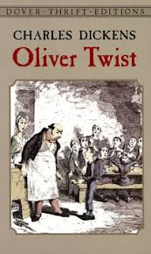

That night, Lyddie decided to read to Rachel to try and calm her down just like Betsy had once done for Lyddie when she was new to the boardinghouse.

Lyddie read Oliver Twist to Rachel until she fell asleep.  Lyddie realized how comforted she was too by listening to the familiar words.

Soon, Rachel was asleep and Lyddie fell asleep too.

That night, Lyddie dreamed of the bear that had come to her cabin.  But this time, Lyddie could not get the bear to leave no matter how hard she tried.  Lyddie knew when she woke up that she was facing many problems in her life right now and that was why she had dreamed of the bear.

In chapter 15 of [Lyddie](https://www.enotes.com/topics/lyddie?en_action=hh_answer_body_click&en_label=%2Fhomework-help%2Fwhat-happens-ch15-lyddie-by-katherine-patterson-474203%23answer-674155&en_category=internal_campaign), we see that work is getting better for Lyddie. She was at first angry that she had to train Brigid, but now she is getting closer to her. Lyddie thinks she is almost done paying off her debts, but her uncle shows up with her younger sister, Rachel, and tells Lyddie that her mother has been sent to an asylum. They need someone else to take care of Rachel now. Lyddie can see that Rachel is too thin and that the young girl doesn't talk. Her uncle also informs her that they are going to have to sell the farm, to pay for her mother's stay at the asylum.

Lyddie is overwhelmed with the new added responsibility. She asks Mrs. Bedlow if Rachel can stay at the boarding house, and she agrees. Lyddie writes to her brother, Charles, to see if he can stop the sale of the farm. At work, Mr. Marsden threatens to fire Brigid, but Lyddie comes to her aid and helps her out. The only peace that Lyddie finds is when she reads Oliver Twist at night.

This chapter shows us that Lyddie is having to face real adult situations. There is added pressure on her, and now that she has to take care of her sister, the pressure is mounting. It is interesting that she finds solace in the words of Oliver Twist, an orphan. Lyddie is becoming more and more like an orphan. She is devastated by the family having to sell the farm, but we also see that Lyddie is becoming more mature and willing to do what she has to do to make things good for her and now her sister.

In chapter 15, Lyddie's uncle and her sister Rachel arrive at the boardinghouse. He has bad news for her: he mother has been sent to an asylum, and the farm is up for sale. Mrs. Bedlow allows Rachel to stay with Lyddie. Lyddie writes to Charles and begs him to stop the sale of the farm.

Even though Lyddie was not pleased with having to train Brigid, when Marsden threatens to fire her, Lyddie offers to help her.